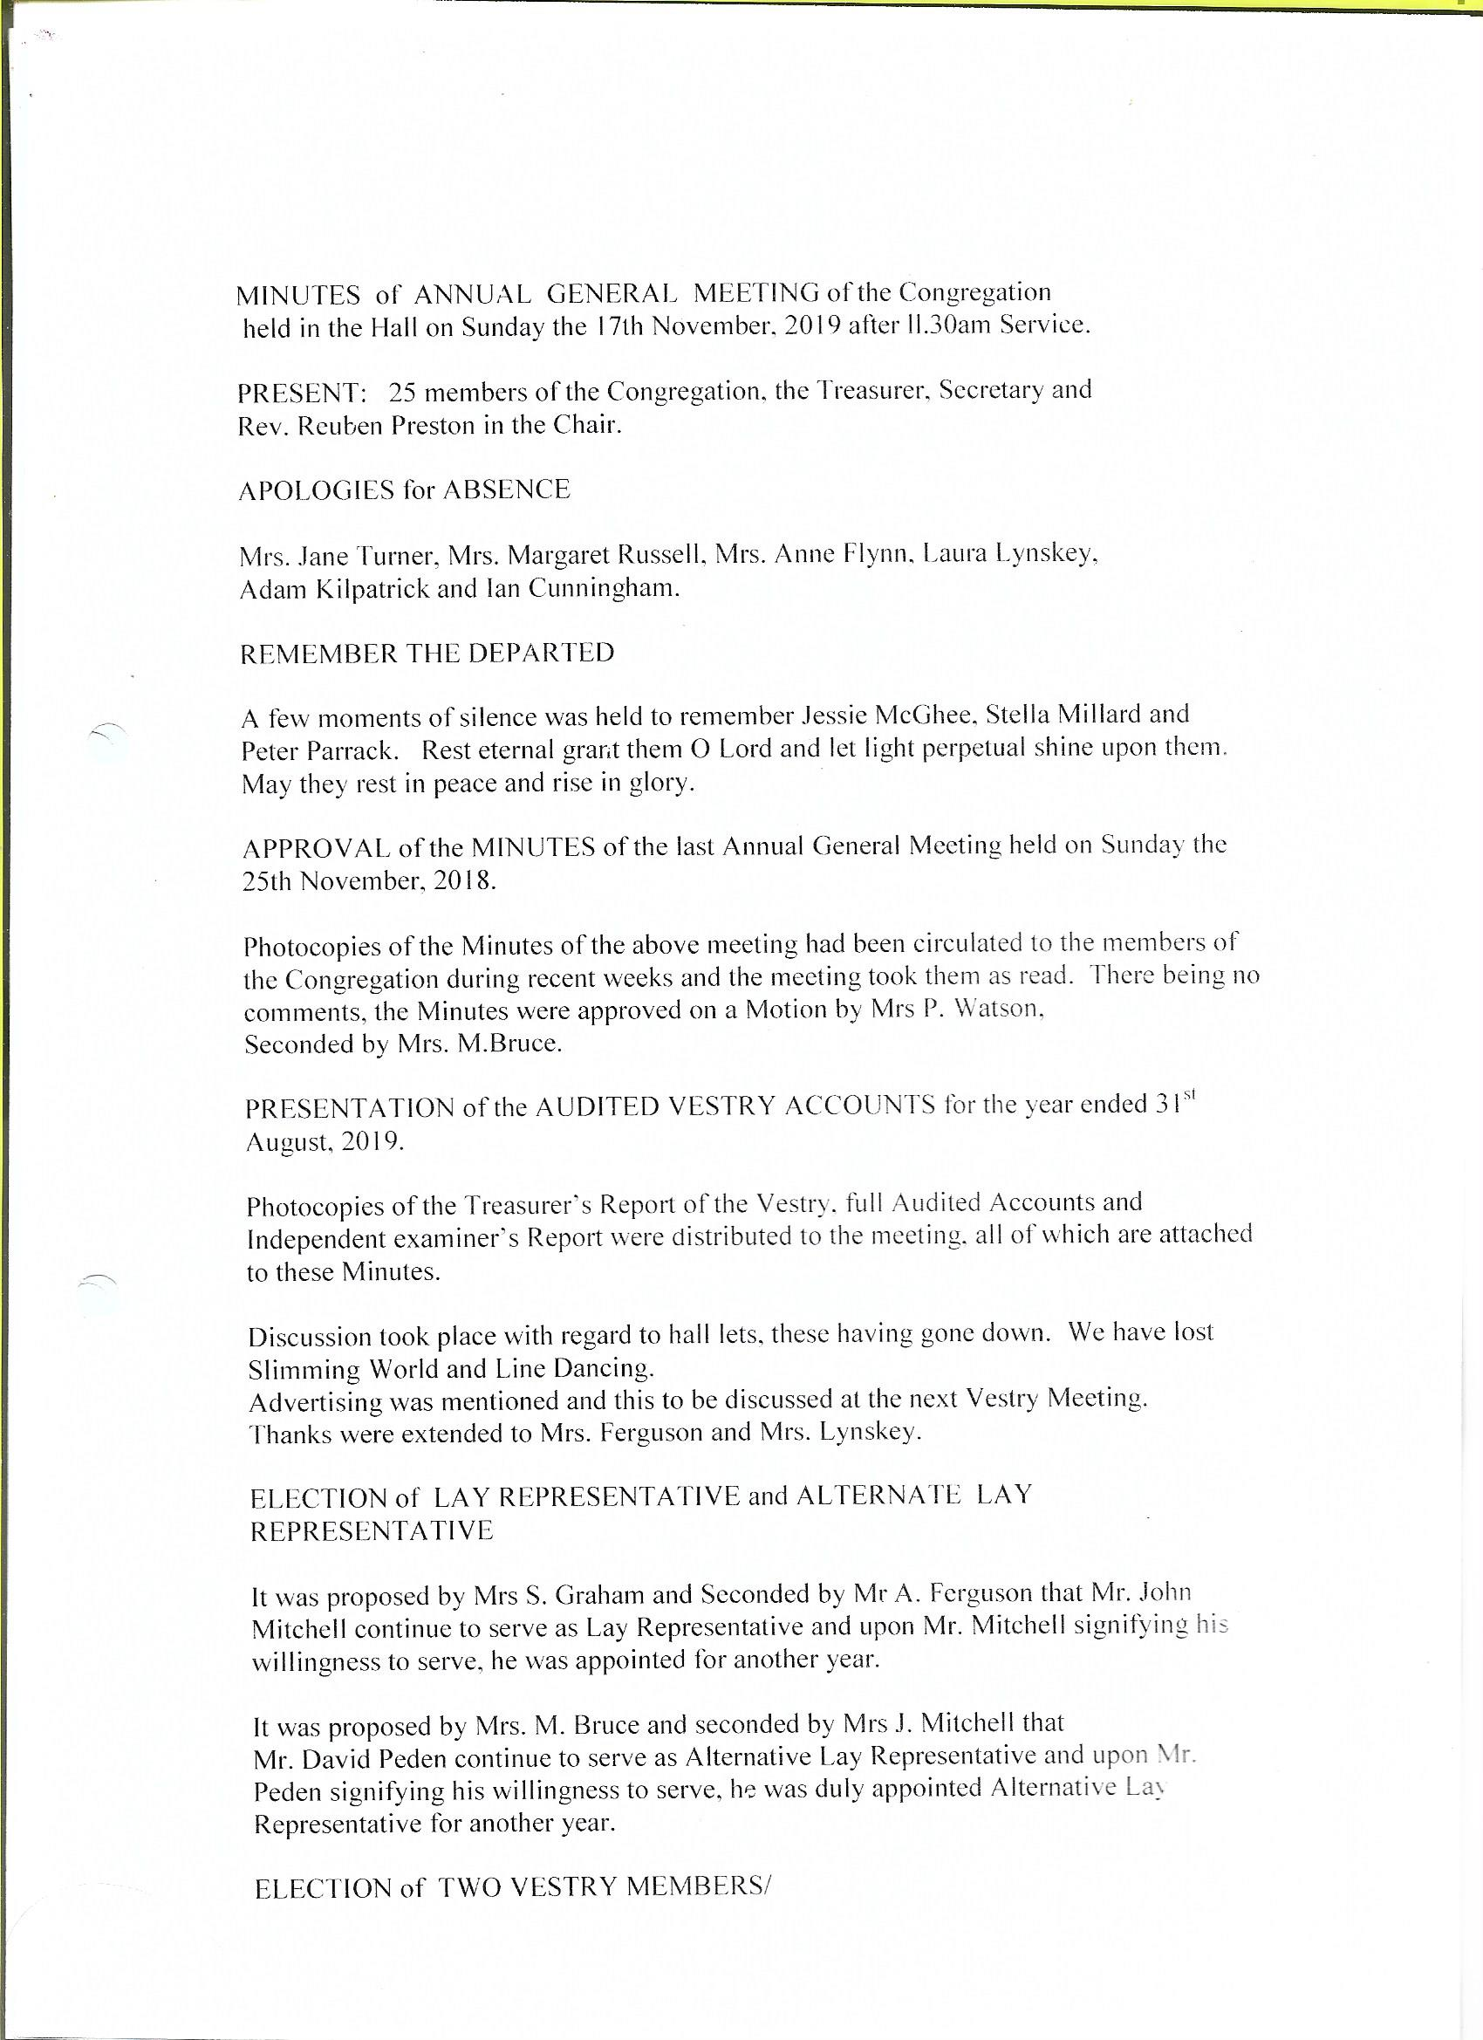

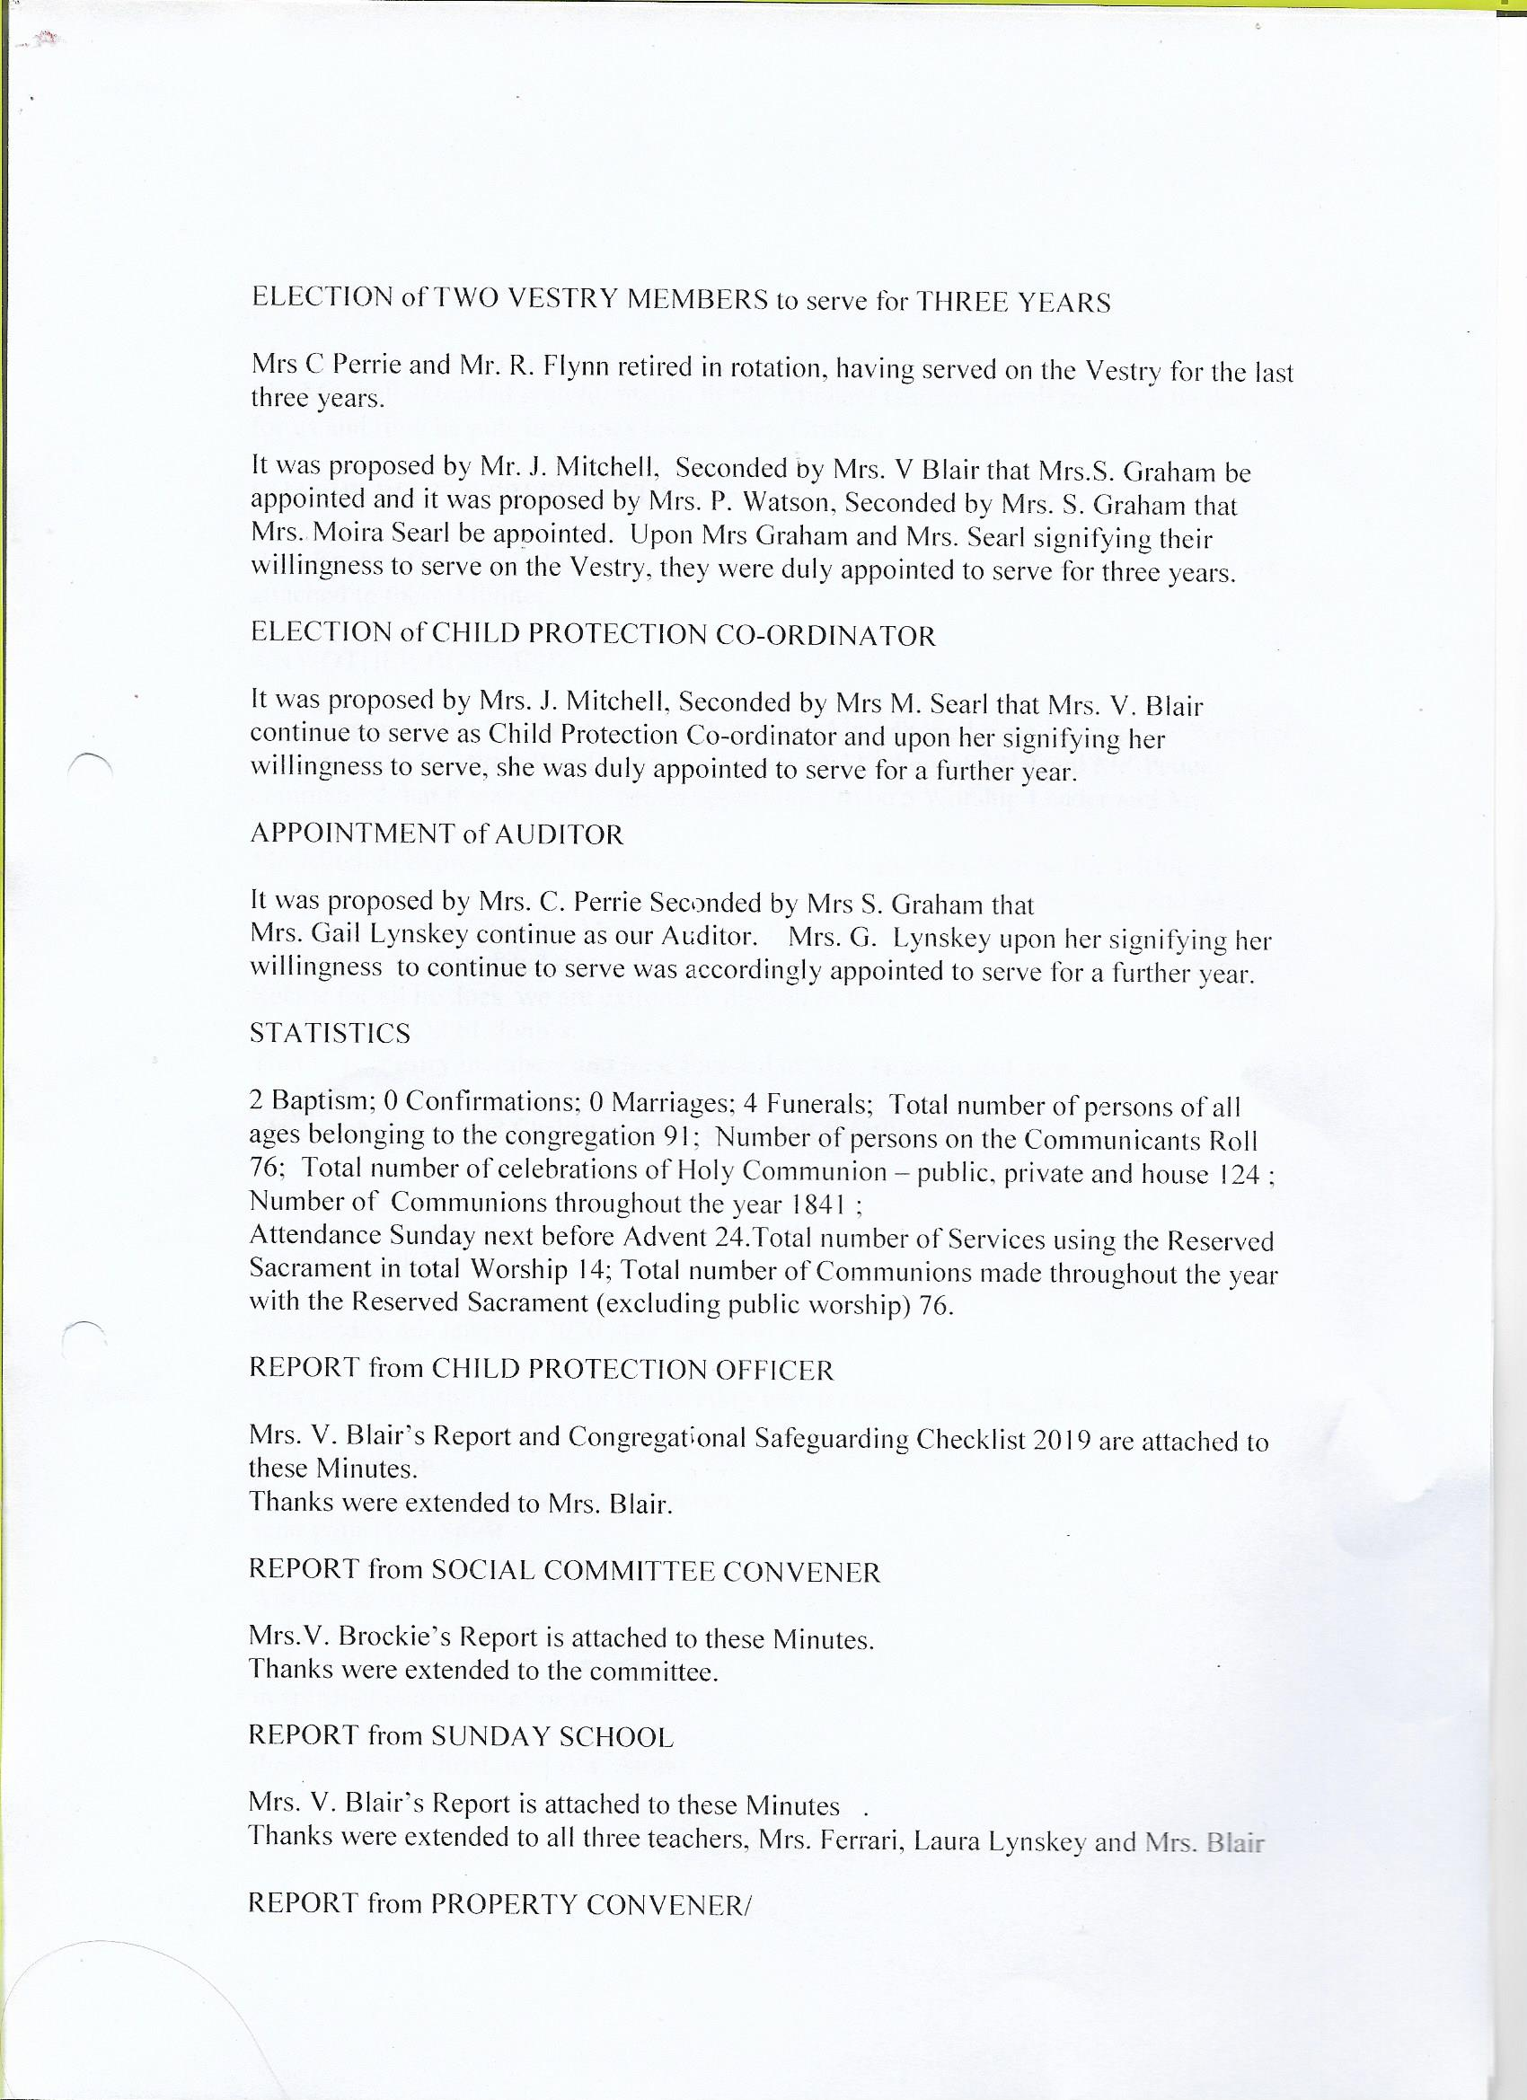

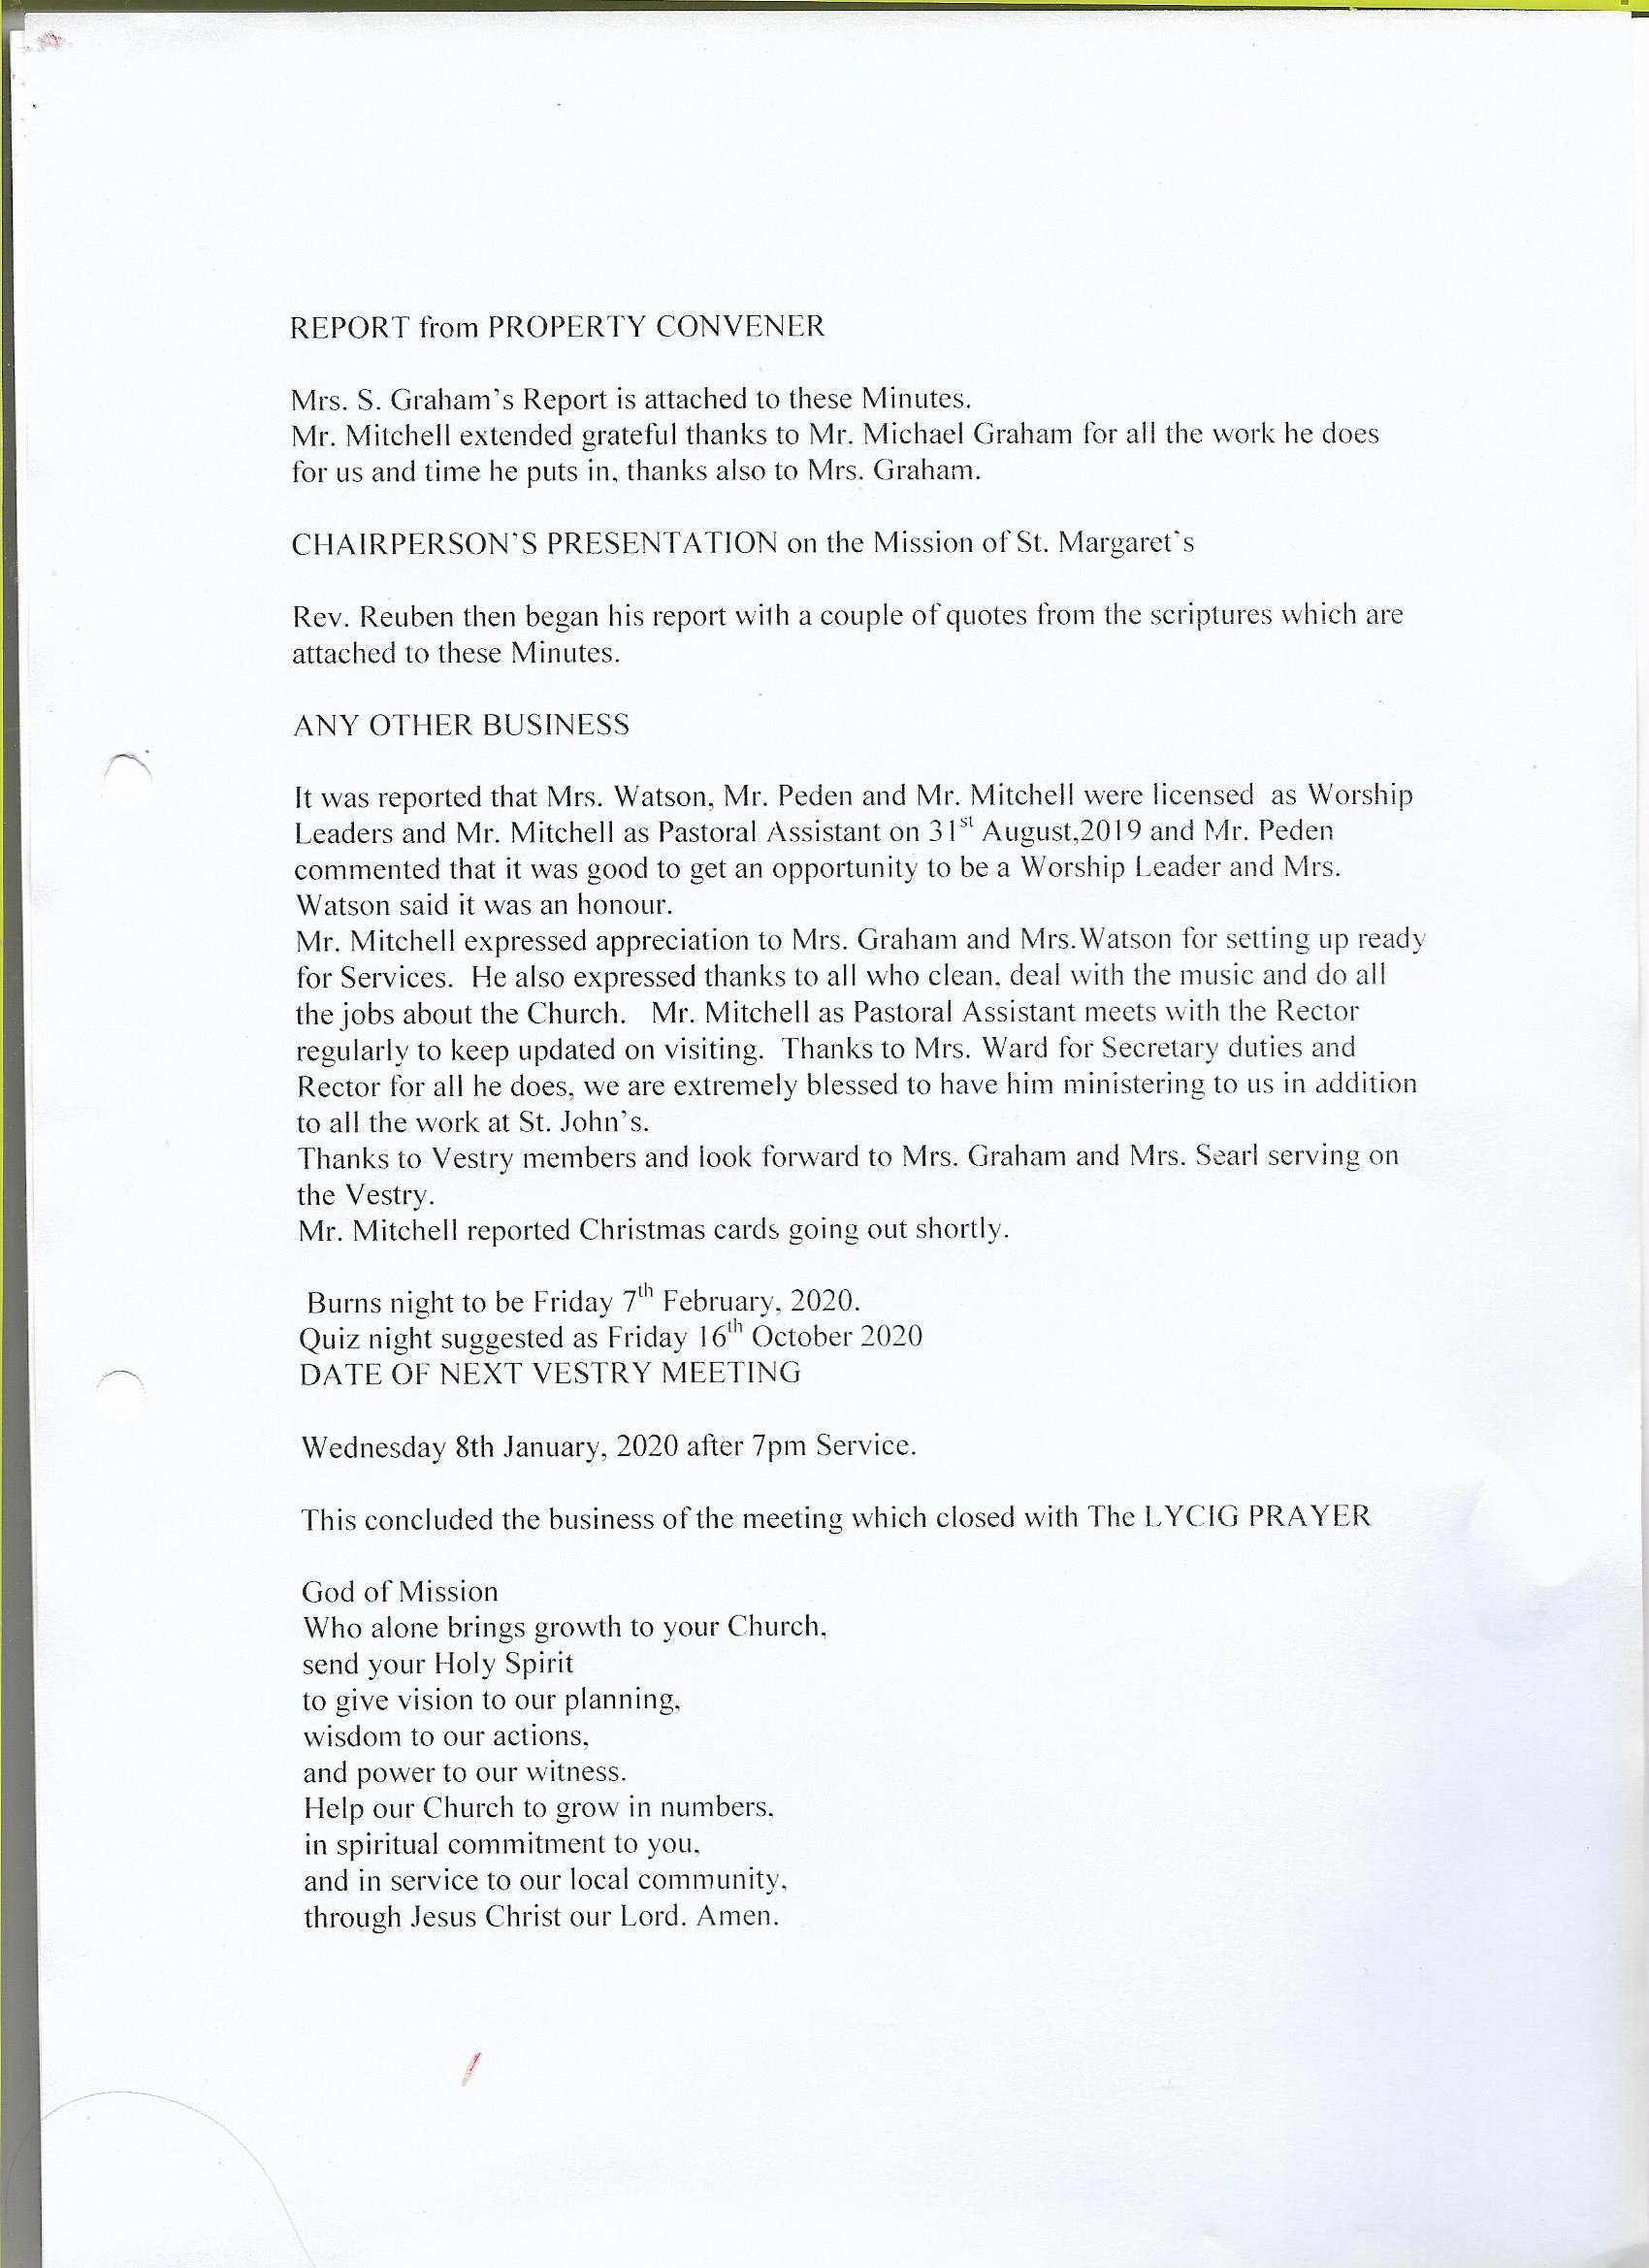

Departed list across the two Charges
Peter Parrack
Norman Sproule
Isabel Roberts
Muriel Gibb
Stella Millard
Marolyn Kennedy
James Arthur
Jackie Pattison
Gillian McGinley
Jessie McGhee
Nancy Geddes
Robert Maxwell

Rest eternal grant to them O Lord
And may light perpetual shine upon them
May they rest in peace
And rise in glory

Rectors report at the 2019 AGM of St Margaret’s Church Renfrew

I want to begin this report with a couple of quotes from the scriptures….

A reading from the Book of Proverbs.
A capable wife who can find?
She is far more precious than jewels.
She opens her hand to the poor,
and reaches out her hands to the needy.
She opens her mouth with wisdom,
and the teaching of kindness is on her tongue.
She looks well to the ways of her household,
and does not eat the bread of idleness.
Her children rise up and call her happy;
her husband too, and he praises her:
"Many women have done excellently, but you surpass them all."
Charm is deceitful, and beauty is vain,
but a woman who fears the Lord is to be praised.
Give her a share in the fruit of her hands,
and let her works praise her in the city gates.
This is the word of the Lord. Proverbs 31. 10, 20, 26-31

Take two let’s change the pronouns to male ones…..

A reading from the Book of Proverbs.
A capable husband who can find?
he is far more precious than jewels.
He opens his hand to the poor,
and reaches out his hands to the needy.
He opens his mouth with wisdom,
and the teaching of kindness is on his tongue.
He looks well to the ways of his household,
and does not eat the bread of idleness.
His children rise up and call him happy;
his wife too, and she praises him:
"Many men have done excellently, but you surpass them all."
Charm is deceitful, and beauty is vain,
but a man who fears the Lord is to be praised.
Give him a share in the fruit of his hands,
and let his works praise him in the city gates.
This is the word of the Lord. Proverbs 31. 10, 20, 26-31

Take three for 2019 going into 2020 when we think about the attitude of people n their relationships and households…

A reading from the Book of Proverbs.
A capable partner who can find?
they are far more precious than jewels.
They open their hands to the poor,
and reaches out their hands to the needy.
They open their mouthes with wisdom,
and the teaching of kindness is on their tongue.
They look(s) well to the ways of their household,
and do(es) not eat the bread of idleness.
Their children rise up and call them happy;
their partner too, and they praises them:
"Many people have done excellently, but you surpass them all."
Charm is deceitful, and beauty is vain,
but a person who fears the Lord is to be praised.
Give them a share in the fruit of their hands,
and let them works praise them in the city gates.
This is the word of the Lord. Proverbs 31. 10, 20, 26-31

DISCORD – who feels it – who feels connection with an including text?
A difference of feelings and a difference of takes on something we have become blind to its exclusive voice.

At my ordination I was called to ‘proclaim the faith afresh to each generation’. Does the younger generation feel different from you?
YES – I should hope so!!!!!!

At the end of St Matthews gospel in chapter 28

The Commissioning of the Disciples
16 Now the eleven disciples went to Galilee, to the mountain to which Jesus had directed them. ¹⁷When they saw him, they worshipped him; but some doubted. ¹⁸And Jesus came and said to them, ‘All authority in heaven and on earth has been given to me. ¹⁹Go therefore and make disciples of all nations, baptizing them in the name of the Father and of the Son and of the Holy Spirit, ²⁰and teaching them to obey everything that I have commanded you. And remember, I am with you always, to the end of the age.’

Do you doubt?
Do you wonder if Jesus is with us?
Do you wonder where God is for you?
Do you have a desire to reach others with he message of Jesus?
Do you wish the Rector would shut up?

This week our St Margret’s Vestry received the news that the application to the Diocese for help in developing the Leading Your Church Into Growth programme was successfully signed off by the Primus. We have £1800 towards helping us to set ourselves up for “Proclaiming the faith afresh to THIS generation”
As a parish priest I cannot over emphasise the degree of support and confidence that the Primus has in me, the Vestry at St Margarets and his desire to see us do the work of Matthew 28 – doubters and worshippers alike.

AGMs are in some churches a time for ego massaging public adulation. I do not want to fall into that trap with us at St Margarets.
We heard this morning about the gentle, committed humility of our patron saint – her dedication in prayer and in good works.
Notice how contemplation and action so frequently work together in the lives of God’s saints.
A dedicated prayer life leads to a dedicated heart – recognising those in need.

So what has all this to do with the LYCIG programme?

Let me explain…….

We have been awared financial reshources to help us grow and foster skills and talents to help our community of St Margarets reach out in in ways – I do not know what they are.
We are about to start on a process which will involve all of us.
We heard how God used St Margaret to reach the heart of her husband, here in 2019 & 2020 God wants to use your lives to reach the hearts of others in Renfrew and the surrounding villages an conurbations.

I want to share with you a few aspect of the LYCIG programme which we shall be considering over the coming years.

ONE – The 4 Ps
Prayer
Presence
Proclaimation
Pursuasion

Do we pray for the growth of St Margarets (or do we want it to just carry on as it is now, without changing, so that its their for my funeral…..?!!)

Presence – how are we a Presence in Renfrew? What is our voice in the ‘market place’?

Proclamation – When do we celebrate ourselves existing as a church?

Pursuasion – how do we engage with people to talk about the life of faith? How do we provide opportunities to allow faith the develop and grow and ask the difficult questions?

TWO – DNA
Desire
plaN
Action

Being organized – with our calender, with our finances, with our invitatons and advertising, with our hospitality and with our welcome and with our preparations.

THREE – the Basic 12 (read out from the book back page)

Our funding bid give us the finances to take 4 peope from ST Margarets (possibly vestry people possibly not) to the Hayes Conferences Centre in Derbyshire for the 4 day LYCIG training conference. Where we meet with other ordinary churches in the Anglican Communion trying to think about how God is calling them to work in their parishes in 2019 ff.
The sort of people we want to go and represent St Margarets are people with a desire to see St Margarets grow – spiritually, numerically and in outreach. We need older folk and younger folk, we need a mix of genders we need people who are happy to work with the vestry and plan a way ahead. It s not any vision which any of us can have as individual but a vision that God will give to us as a community.
Do you want to be a part of it?
Have a think.. Have a chat to people you think you be good at it…. Don’t discount anyone for any reason….take your musings to your prayers and ask God to reveal who God is calling to this role for St Margarets……..

This is a great opportunity we have been given by the Regional Growth Fund and the Primus……let us pan and work and pray for growth in every aspect of St Margaret’s life.

A place where all are valued, all are included, where we are aware of the work of the Spirit in the world and where we bring to our worship our lives in all their wholeness’s.

May we have the compassion and perseverance of our patron St Margaret.

¹⁷When they saw Jesus, they worshipped him; but some doubted. ¹⁸And Jesus came and said to them, ‘All authority in heaven and on earth has been given to me. ¹⁹Go therefore and make disciples of all nations, baptizing them in the name of the Father and of the Son and of the Holy Spirit, ²⁰and teaching them to obey everything that I have commanded you. And remember, I am with you always, to the end of the age.’

